PROJECT TITLE: PRODUCT INVENTORY MANAGEMENT

TEAM LEADER: Rukmani M
rukmanimeera071@gmail.com

TEAM ID: SWTID-2026-2573
TEAM MEMBERS:
Archana R-archanar7200@gmail.com
Rasathi P- rasathip329@gmail.com
Swetha C-
cchakravarthi644@gmail.com

PROJECT OVERVIEW
The Product Inventory Management System is a backend web application built using Node.js, Express.js, and MongoDB. It provides a reliable and secure platform to manage product information through REST APIs.
The system allows users to create an account, login securely, and access protected APIs using JWT authentication. Only authorized users can perform operations in the system.
It supports complete CRUD operations, enabling users to add products, view their inventory items, update product details like price or quantity, and delete products when necessary.
Key Objectives:
* Implement secure JWT authentication for user access control.
* Provide an efficient inventory management system using REST APIs.
* Ensure that every user can access and manage only their own product data.
* Build a scalable backend structure using Node.js, Express.js, and MongoDB.
* Deliver fast API responses with proper validation and error management.
Target Users:
* Small business owners who manage stock or product records.
* Freelancers and online sellers tracking their services or items.
* Developers who want to learn backend API development and authentication.
* Students working on backend or full-stack academic projects.
* Anyone who needs a simple and secure backend system for product management.
PROJECT INSTRUCTION
* Create a backend project directory
* Configure the Express server
* Establish MongoDB database connection
* Develop authentication APIs
* Implement product CRUD APIs
* Test all APIs using Thunder Client in VS Code

PRE-REQUISITES
Software | Purpose
Node.js | JavaScript runtime for backened
MongoDB | Database Storage
npm | Package manager
VS Code | Development environment

Knowledge Requirements
* JavaScript ES6 concepts
* Node.js and Express.js REST API development
* MongoDB and Mongoose ODM
* JWT authentication
* Middleware architecture
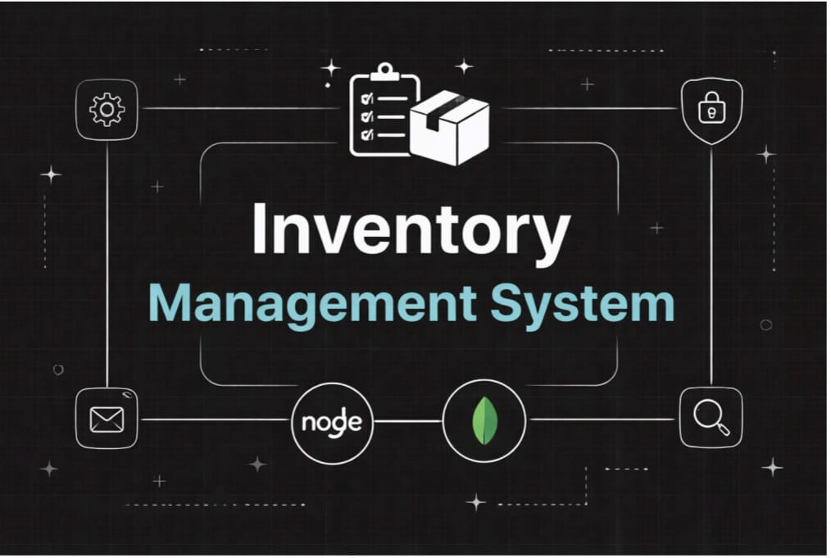
PROJECT ARCHITECTURE
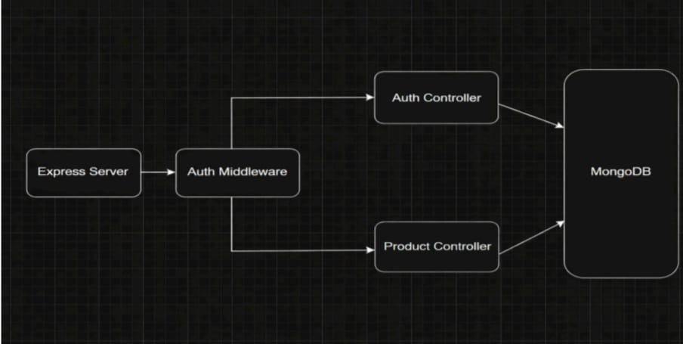
Auth Controller:
The Auth Controller is responsible for managing all authentication activities in the application. It handles user registration and login while ensuring secure access through JWT tokens.
Responsibilities
* Register new user accounts
* Validate user input information
* Encrypt passwords using bcrypt before saving them
* Verify user credentials during login
* Generate JWT tokens for authenticated users
* Return appropriate success or error responses
Product Controller
The Product Controller manages all inventory-related operations and contains the logic for handling products associated with individual users.
Responsibilities
* Add products to the inventory
* Retrieve products created by the logged-in user
* Modify product details such as price, quantity, or description
* Remove products from the system
* Implement search functionality for products
Create:src/middleware.js
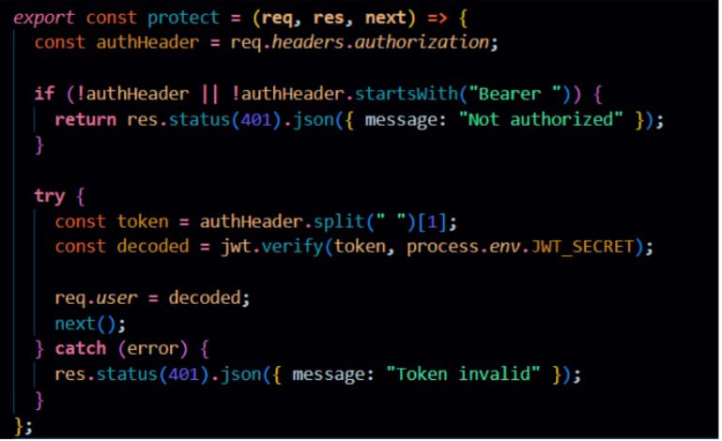
Database Architecture (MongoDB)
Users Collection:
* _id
* name
* email
* password (hashed)
* timestamps
Products Collection:
* _id
* userId (reference to user)
* name
* price
* quantity
* description
* timestamps
Relationship: One User → Many Products
Indexes:
* email (unique)
* userId
* product name
Auth Middleware
The Auth Middleware protects private routes by verifying the JSON Web Token (JWT) included in the request header.
It checks whether the request contains a valid Authorization header with “Bearer token” format. If the token is verified successfully, the decoded user details are attached to req.user, and the request continues to the next function.
If the token is missing or invalid, the middleware returns a 401 Unauthorized response, preventing access to protected endpoints.
Create:
Auth.routes.js
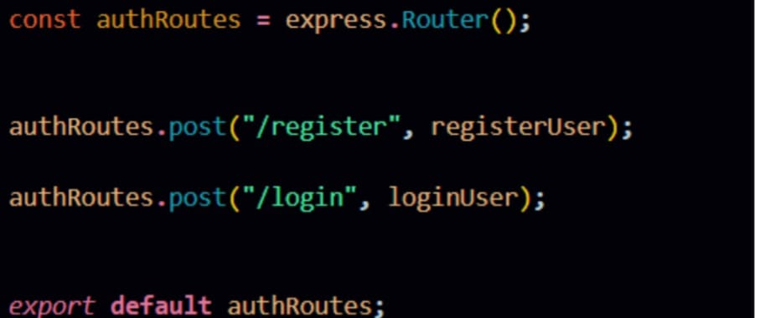
Product Routes:
Product routes manage all inventory-related operations such as creating, retrieving, updating,
and deleting products. These routes are protected using authentication middleware to ensure
only authorized users can access their own product data.
Connect Routes to Server
Import all routes into server.js
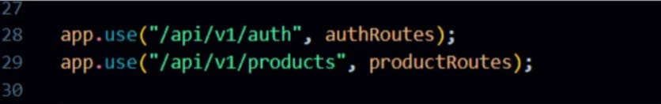
These route configurations connect the authentication and product APIs to the main Express
server using versioned endpoints. The /api/v1/auth path handles all user authentication
requests, while /api/v1/products manages product-related operations, helping maintain a
structured and scalable API architecture.
Database Configuration and Setup
● Create MongoDB Atlas cluster
● Add connection string to .env
● Connect DB before API testing.
Database Connection:
Create a file inside: src/db/db.js
Purpose: Connect backend to MongoDB using mongoose.Roles and Responsibility
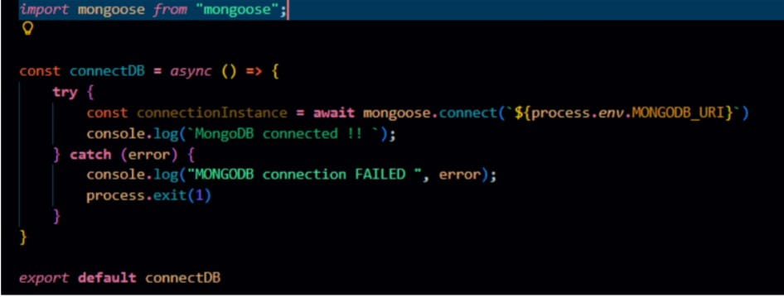
User model:
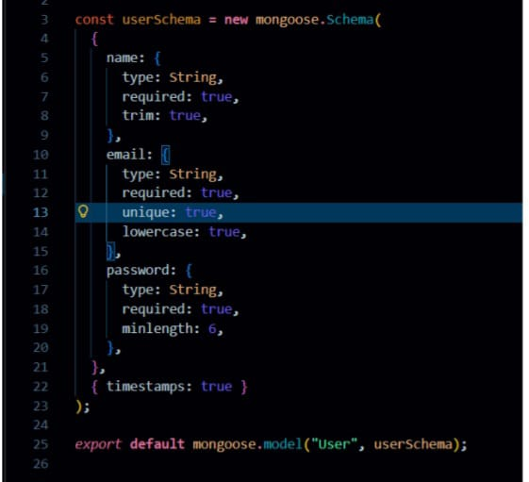
User
Registration: Register using name, email and password
Login: Login using registered credentials
Add Product: Create product with name, price, quantity and description
Edit Product: Update existing product
Delete Product: Remove product from inventory
Search Product: Search products using keyword
User Flow
1. The user sends a register/login request.
2. The backend generates a JWT token.
3. The user sends a token in the Authorization header.
4. Middleware verifies the token.
5. The controller performs CRUD operations.
6. MongoDB stores or retrieves product data.
7. API sends response.
API Testing :
Use Thunder Client to test APIs:
Test APIs:
Register User:
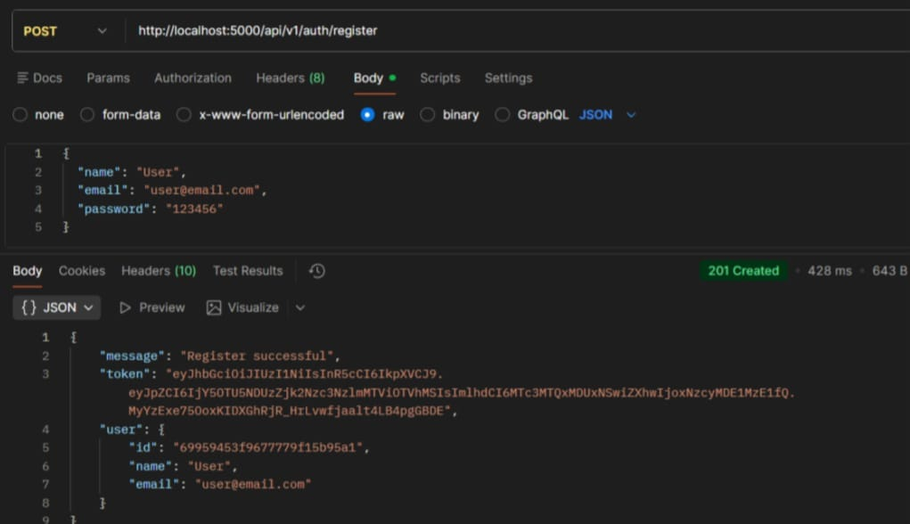
Register:
The register functionality allows new users to create an account by submitting their details,
which are validated and securely stored with a hashed password. It ensures unique user
creation before granting access to the system.
Login User
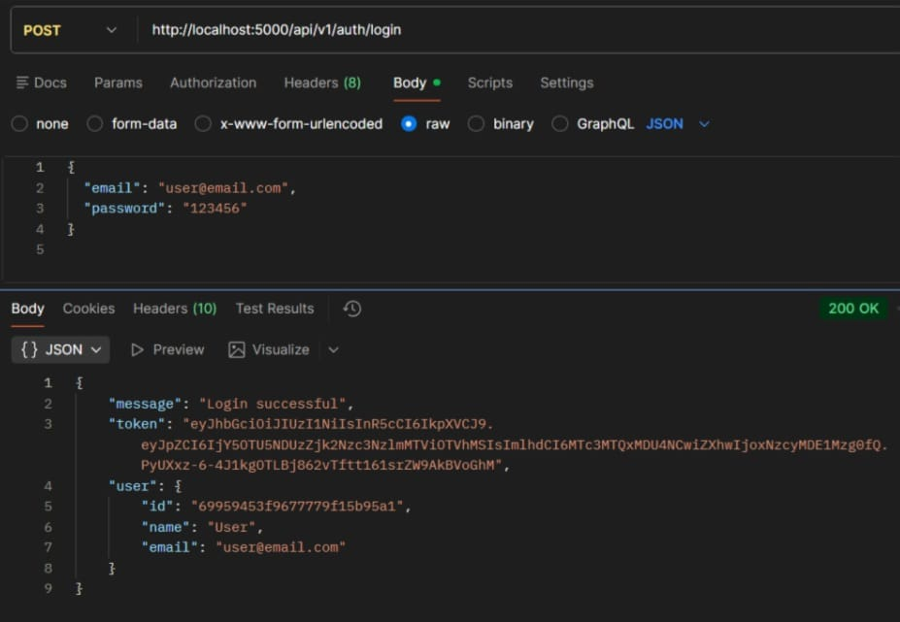
Login:
The login functionality verifies user credentials and generates a JWT token upon successful
authentication. This token is used to access protected routes securely.
Create Product
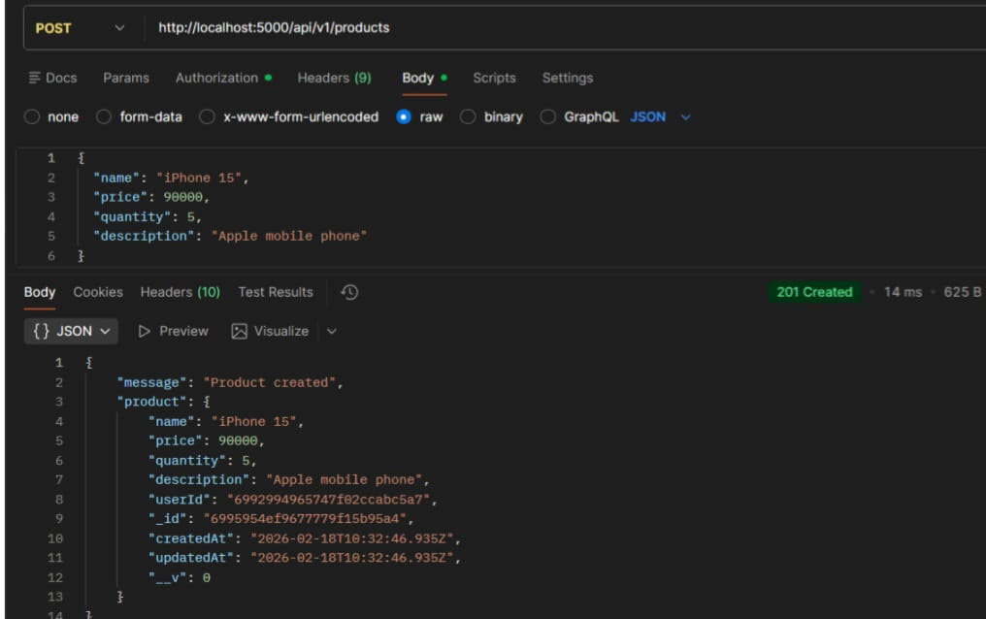
Create Product:
Allows an authenticated user to add a new product to their inventory by submitting product
details. The product is saved with the user’s ID to maintain ownership.
Get all Products
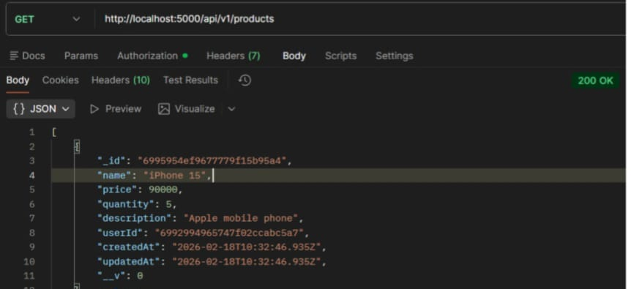
Get all Products:
Fetches all products that belong to the logged-in user. It ensures users can view only their own
inventory data.
Update Product
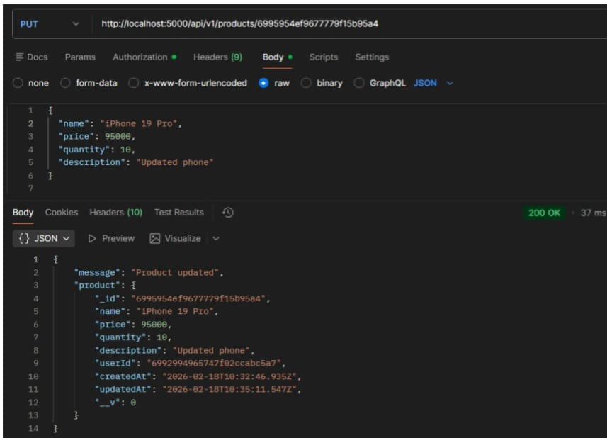
Update Product:
Enables users to modify existing product details such as name, price, or quantity. The system
verifies ownership before allowing any updates.
Delete Product
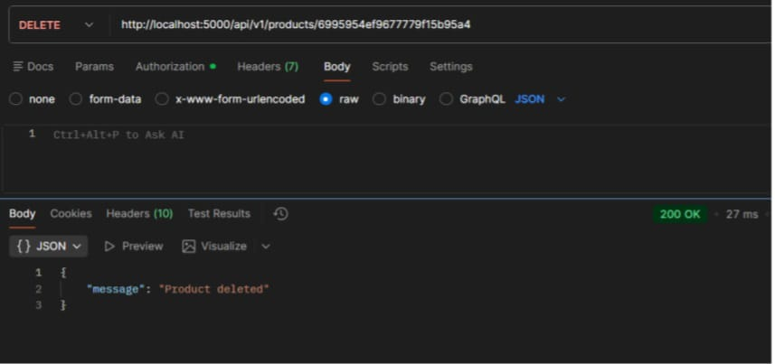
Delete Product:
Allows users to permanently remove a product from their inventory. The operation is protected
to ensure only the product owner can delete it.
Project Demo Video: Nm project vd.mp4

